iOS SDK Manual Integration Guide

I. Overview

This guide will help you manually integrate IDOSDK into your iOS project to implement specific functions and features.

II. Preparation

1. Make sure you have installed the Xcode development environment and are familiar with the basic process of iOS development.
2. Download the latest version of IDOSDK ([download](https://github.com/idoosmart/ios_sdk_full/archive/refs/heads/main.zip)) (simulator is not supported).
3. Unzip the downloaded IDOSDK zip file and copy it to the project (optional)

III. Access steps

1. Add SDK files to the project
   * Find the downloaded SDK files, which usually include one or more framework files and resource files.
   * Drag these files into your Xcode project, making sure to select the "Copy items if needed" option to copy the files to the project directory.  
     Note: If you have copied to the project directory in step 2.3, you do not need to select the "Copy items if needed" option. Refer to 3 in (Figure 3-1)

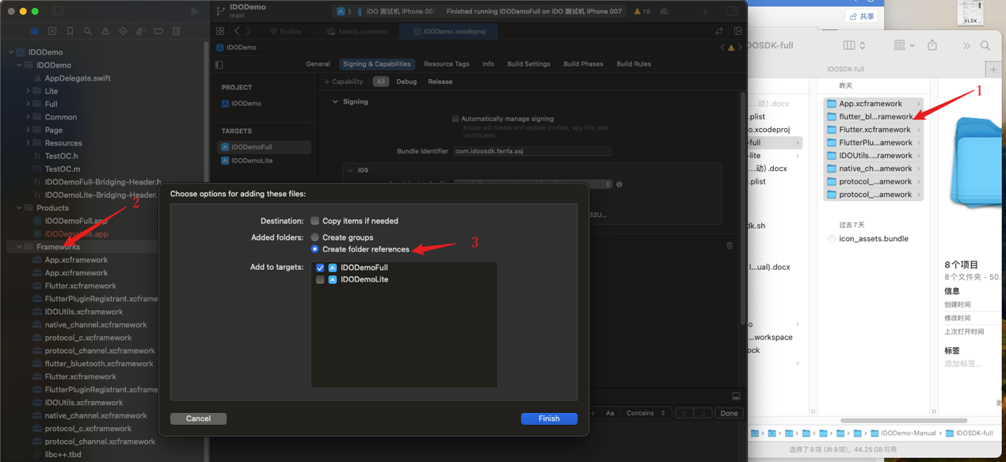

（Figure 3-1）

1.Unzip and copy the IDOSDK related framework to the project

2.Project Frameworks location

3.Select association

In the project's "General" settings, make sure the added SDK file is included in the "Linked Frameworks and Libraries" list.  
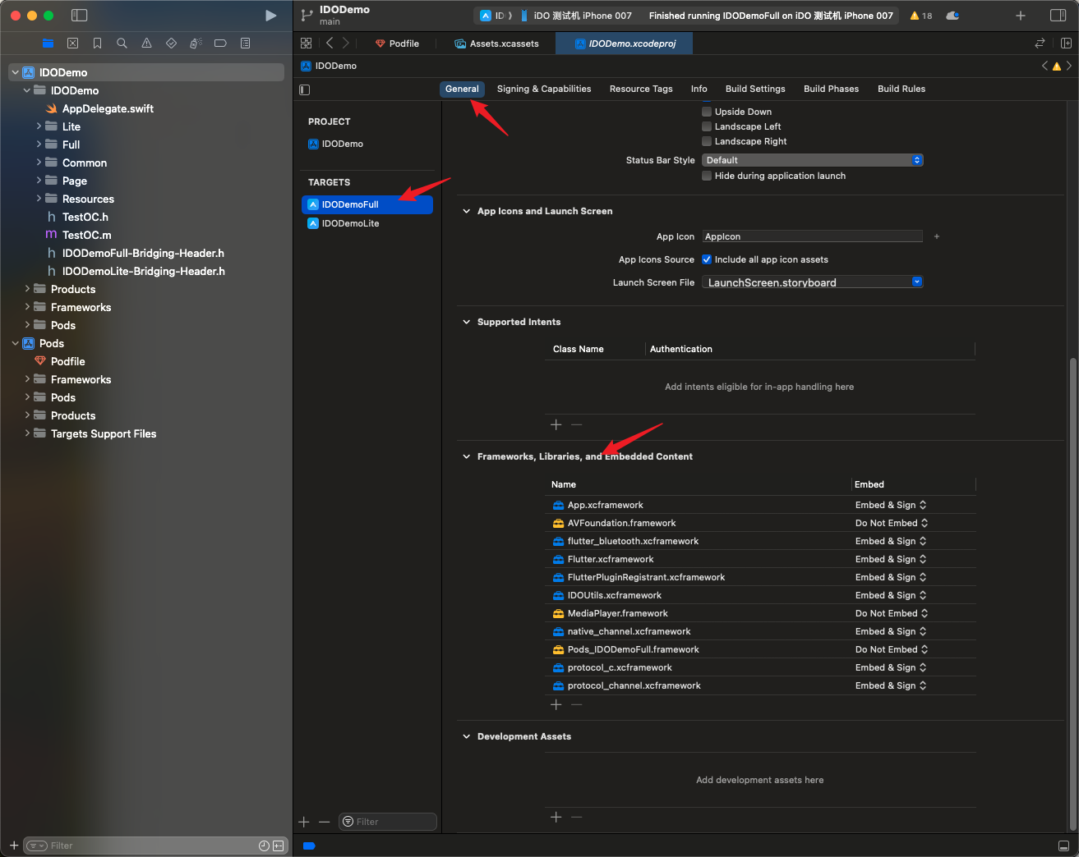  
（Figure 3-2）

* + According to the requirements of the SDK, you need to set some specific parameters in "Build Settings"

Configure necessary macro definitions:

PLATFORM_TYPE=2

HAVE_INTTYPES_H

HAVE_PKCRYPT

HAVE_STDINT_H

HAVE_WZAES

HAVE_ZLIB

VAR_ARRAYS

USE_ALLOCA

NONTHREADSAFE_PSEUDOSTACK

OPUS_BUILD

STDC_HEADERS 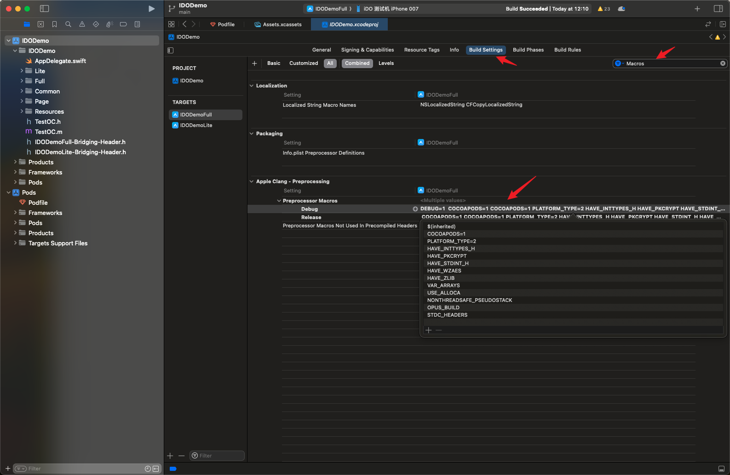  
（Figure 3-3）

1. Add system libraries

libz.tbd

libc++.tbd

libiconv.tbd

1. Use SDK
   * For specific usage, refer to Demo ([view](https://github.com/idoosmart/Native_Demo))

IV. Common problems and solutions

1. Compile errors

1. If a compile error occurs, check whether the header file path is set correctly and whether the required framework is linked correctly.

2. Make sure that the architecture settings of your project are consistent with the architecture required by the SDK.

2. Runtime Errors

1. If an error occurs at runtime, check that the initialization code is executed correctly and that the correct parameters are passed.

2. Check the log output for more information about the error.